**Vehicle Configurator (V-CONF)**

**Business Requirement Document**

###### **V 1.2**

| PREPARED BY | Jayant Ponkshe |
| --- | --- |
| DATE | 25-Mar-13 |

**Document Control:**

| **VERSION** | **AUTHOR** | **DATE** | **CHANGE DESCRIPTION** | **APPROVER & DATE** |
| --- | --- | --- | --- | --- |
| 0.01D | Jayant Ponkshe | 30-Oct-08 | Initial Draft |  |
| 1.0 | Jayant Ponkshe | 13-Nov-08 | Final Doc |  |
| 1.01D | Jayant Ponkshe | 20-Aug-12 | Changes Done |  |
| 1.1 | Jayant Ponkshe | 20-Aug-12 | Baseline |  |
| 1.02D | Jayant Ponkshe | 25-Mar-13 | e-Mail updated |  |
| 1.2 | Jayant Ponkshe | 25-Mar-13 | Baseline |  |

Table of Contents

**1.** **INTRODUCTION 4**

1.1. Purpose 4

1.2. Scope 4

*1.2.1.* *In-Scope 4*

*1.2.2.* *Out of Scope 4*

**2.** **SUMMARY OF REQUIREMENTS 4**

2.1. General 4

**3.** **DETAILED REQUIREMENTS 6**

*3.1.1.* *Home page 6*

*3.1.2.* *Sign-On 8*

*3.1.3.* *Registration 9*

*3.1.4.* *Welcome Page 9*

*3.1.5.* *Default Configuration 11*

*3.1.6.* *Configure 12*

*3.1.7.* *Invoice 13*

**4.** **GENERAL INFORMATION 14**

**5.** **POINT OF CONTACT 14**

# **Introduction**

This document is prepared for the students of Vidyanidhi’s IT institute C-Dac diploma course.

## **Purpose**

The purpose of the functional requirement (or business requirement) document is to define and document a complete and accurate description of the requirements/specifications of the product to be developed for vehicle configurator.

## **Scope**

### **In-Scope**

All requirements specified as “Mandatory” or “Must to have” are in the scope of this project. All such requirements are required in order for the product to be considered complete for this project.

### **Out of Scope**

All requirements specified as “Optional” or “Nice to have” may be considered as out of scope of this project. All such requirements are not required for the product to be considered complete however if feasible, the product shall include these requirements. Future projects may be initiated to deliver optional requirements not included in the product of this project.

***Note: All requirements shall be considered mandatory unless specified otherwise.***

# **Summary of Requirements**

## **General**

Except Home page most of the screens will look like as fig-1. This can be considered as a template for all pages (except home page) unless specified explicitly.

| **No** | **Requirement** | **Priority** |
| --- | --- | --- |
| 01 | Site should be compatible for IE browser v 6.0 (SP2) and above | Mandatory |
| 02 | Site should be compatible for Netscape 7.1 and Mozilla Firefox 2.0 and above | Optional |
| 03 | Multilingual Site | Nice to have |
| 04 | Bottom Links | Mandatory |
| 05 | Mouse-over menu for Top-menu bar (and wherever applicable) | Nice to have |
| 06 | “Back” option of browser to be blocked (provide back button on each page) | Optional |
| 07 | Sign-on page | Mandatory |
| 08 | About US | Low |
| 09 | History | Low |
| 10 | Financial results | Low |
| 11 | Offices | Low |
| 12 | Contact us | Mandatory |
| 13 | Registration (Download form) | Mandatory |
| 14 | Registration (On Line) | Mandatory |
| 15 | Welcome Page | Mandatory |
| 16 | Default configuration page | Mandatory |
| 17 | Configuration page | Mandatory |
| 18 | Print Invoice | Mandatory |
| 19 | Invoice generation in .PDF format | Nice to have |
| 20 | Sending request to Vendor’s application and get the quotation (response from the that application) | Nice to have |
| 21 | Sending request to credit card authorization to external apps | Nice to have |

Fig-1.

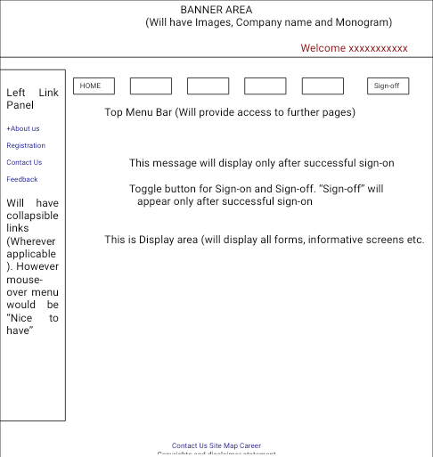





# **Detailed Requirements**

This session will depict the requirements in detail page by page. Necessary screen template needs to be applied. You may change the screen layout with prior acceptance. However, the changes to the template should not hamper basic skeleton at large extent and consistency should be maintained across the screens.

### **Home page**

The home page will have brief about company and its services. It will have links on top menu as follows: (Pl. refer Fig. –2). The button “About us” may be provided with Mouse-over menu (Optional). However it should have on-click menu as described. The top menu bar will remain on all pages unless mention otherwise.

“Sign-on”

About Us

Contact us

Registration

* **Sign-on:** On click this should redirect to Sign-on page.
* **About Us**: This will have following options either on click (or as mouse-over)
  + - **History:** This will pop-up company history and milestone achieve.
    - **Financial results:** This will display a page with last balance sheet
    - **Management:** This will display a brief about Board of directors
    - **Offices:** This will display address of all branches
* **Contact Us**: This will lead to the page where one can put comments. This page will have “Submit” and “Cancel” button. On “submit” the mail will be sent to specified mail id. (Mail id will be provided later). And “Acknowledge page” will appear with OK button. On OK, it will redirect to the page where user has come from.
* **Registration**: This will take user to registration page.

Fig-2 (Home Page)

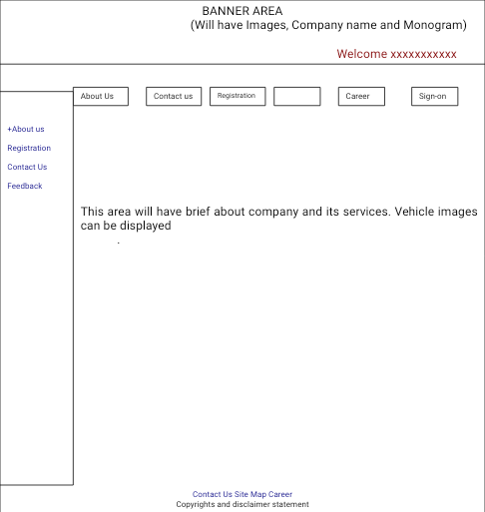

### **Sign-On**

Sign-On page will allow user to enter user id and password. Both the fields are mandatory to enter. On Sign-on the system will authenticate the use and either allow or denied access (with relevant message). On three unsuccessful attempts of sign-on the user access will be blocked.

Fig. –3 (Sign-On page)

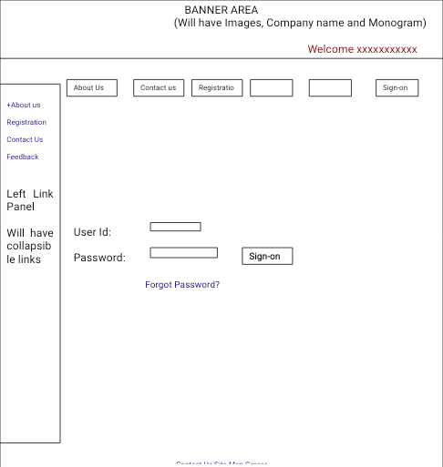

### **Registration**

This will be the registration page for new user. Any company (not an individual) can apply for registration. The form will display with following fields. Mandatory fields should be marked with *. At the bottom there will be two buttons “Submit” and “Clear”. On submit, the mail will be generated with the details filled in form to specified id. Also, confirmation mail along with registration number and form details will be sent to user.

Fields will be as follows

Name of the company:

Address: Line –1, Line-2, Area – City/town:, State, Pin –

Tel: Fax

Holding: Proprietary / Pvt. Ltd / Ltd

Name of the Authorized person:

Designation:

Tel Cell

Company’s ST No

Company VAT Reg. No:

I Tax PAN: (if needed)

Alternatively, The form can be provided in .PDF format, which can be download.

### **Welcome Page**

This page will be displayed only to authorized users. With this page users will able to select following.

**Class/Segment of vehicle:** Available Options are Small Car, Compact Car, Sedan, SUVs, and Luxury car.

**Manufacturer:** On selection of Class, the user will able to select the manufacturer from dropdown list.

**Model:** Further the dropdown list of models (manufactured by selected manufacturer) should be available for selection.

**Quantity:** This field will be pre-filled with minimum quantity. User can overwrite the quantity however, quantity below min quantity is denied. The criteria for min. quantity is as follows.

| **Segment** | **Min. Quantity** |
| --- | --- |
| Small Car | 8 |
| Compact Car | 6 |
| Sedan | 5 |
| SUVs | 3 |
| Luxury Car | 2 |

There will be “Go” button to proceed further. On Go, it will redirect to default configuration page.

Fig. – 4

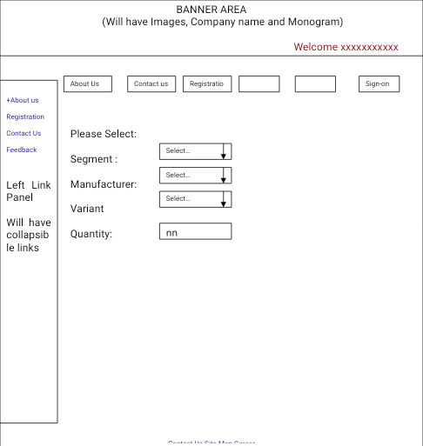

### **Default Configuration**

This page will display the vehicle’s default configuration and price. The page will have “Confirm order” “Configure” and “Modify Selection” button.

**Confirm Order:** Will display final invoice page.

**Configure:** This will take to the page where user will able to configure the vehicle

**Modify Selection:** This will take user back to Welcome page

The page will look like –

Fig. –5 (Default Configuration)

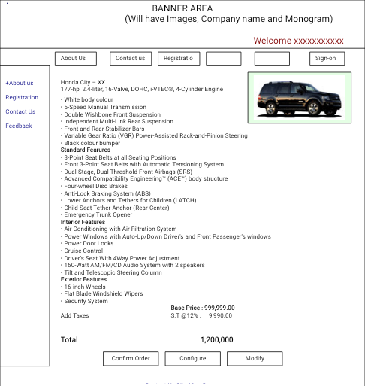

### **Configure**

This screen will allow user to configure the vehicle. All configurable Items will have drop down list to select (Refer Fig. –6). In drop down list the item names and price will be listed. The price for configurable item will be “In-lieu of” price. The buttons “Std. Features”, “Interior” and “Exterior” will allow user to configure respective items. All screens will look similar. “Confirm order” Will display final invoice page. “Cancel” will take user to Default Configuration page.

Fig. –6

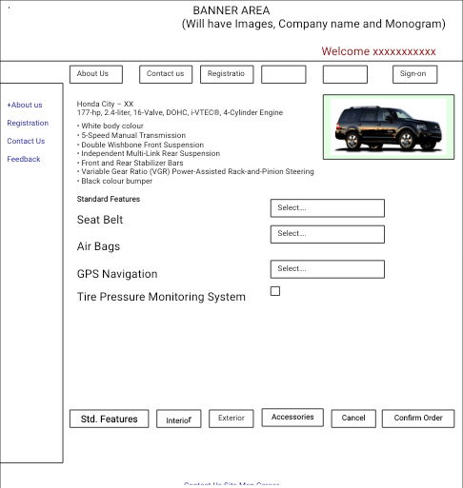

### **Invoice**

This page will display the invoice with configured items and selected accessories (with Prices). It will also calculate the Amount and various taxes on it. There will be “Cancel”, “Confirm” and “Print” button. Cancel button will take back to previous page. Confirm button will save the order and invoice will be sent to customer thru mail. Print button will allow user to print the invoice. On “Confirmation” the purchase order (PO) will be sent to respective vendor. Both, the invoice and PO should be converted into .PDF format before sending thru mail (Nice to have).

# **General Information**

* Team leader need to submit status report every week
* All milestone need to be submitted as per schedule
* Any change (if needed) in system will require prior approval
* Assumptions made should be informed and should have approval.

# **Point of Contact**

All queries may be sent to Jayant Ponkshe thru mail [jayant.Ponkshe@gmail.com](mailto:jayant.Ponkshe@gmail.com) or may be discuss in person.

********** This page is kept blank intentionally **********